**Project Overview – *Market Price of Agriculture Commodities***

**Tool Used: Power BI**

**Data Used: Commodity names, market counts, modal prices, grading levels**

**Problem Statement**

Farmers, traders, and policymakers often struggle to keep track of how agricultural commodity prices vary across markets. Price fluctuations due to quality, location, and supply-demand mismatches create confusion and missed opportunities. Without a clear, consolidated view, stakeholders risk making poorly informed decisions that impact profitability and policy effectiveness.

**Project Abstract**

This dashboard brings transparency to agricultural commodity pricing by analysing data from over 1200 markets and 200+ commodities. With interactive visuals, it shows trends in modal prices, highlights top-value crops, and visualizes how markets are graded. It's designed to support smarter decisions around pricing, trading, and policy formulation.

**What We Built (Proposed Solution)**

We created an interactive Power BI dashboard that breaks down:

* The **average and highest modal prices** for each commodity
* How **commodities are spread** across markets
* **Price ranges** (min, max, modal) for better comparison
* The **distribution of markets** by quality grade (like A, B, C, FAQ)

This gives users — from farmers to government planners — a powerful visual tool to understand and act on commodity pricing data.

**Project Workflow**

**What the Dashboard Shows (Output)**

**KPI Summary Cards**

* **Total Commodities**: 217
* **Total Markets**: 1271
* **Average Modal Price**: ₹4,858.66
* **Top Priced Commodity**: Cardamom

**Charts & Visuals**

* **Bar Chart**: Average modal price by commodity
* **Count Chart**: Number of markets selling each commodity
* **Clustered Bar**: Comparison of min, max, and modal prices
* **Pie Chart**: Market count by grade (A, B, C, FAQ)

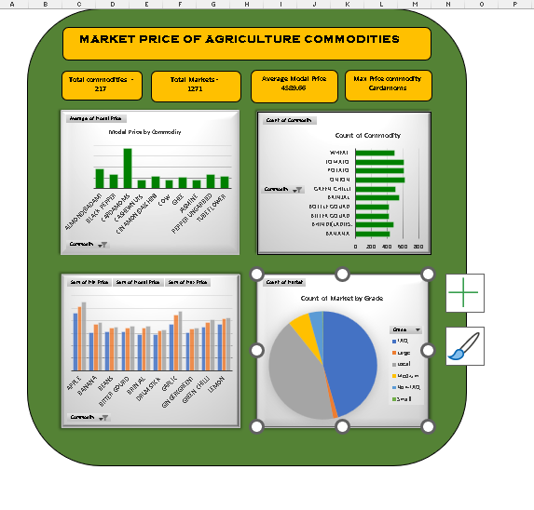

**Future Improvements**

* **Live data connection** from APIs like Agmarknet or eNAM
* **Geo-maps** showing district-wise price movement
* **Price prediction models** based on weather and season
* **User-focused filters** for farmers to track specific crops
* **Mobile-friendly version** for real-time market access on the go